REVISION FOR THE SECOND TERM------ Name : ___________________ Class: 11a

TEST 1 “LUCK IS FOR THE LAZY, SUCCESS IS FOR THOSE WHO WORK HARD”
Question 1: A. secure B. rugby C. indulge D. shuttle
Question 2: A. capture B. effort C. scenic D. survive
Question 3: Only a few of the movie showing at the Gray Theater are suitable for children.
A B C D
Question 4: We are proud of our ______ staff, who are always friendly and efficient.
A. well-done B. well-appointed C. well- behaved D. well-trained
Question 5: We should develop such ______ sources of energy as solar energy and nuclear energy.
A. tradition B. alternative C. surprising D. revolutionary
Question 6: Although they didn’t win, they were able to take some ______ from their performance.
A. satisfaction B. satisfactions C. satisfactory D. satisfying
Question 7: Before he turned 14, Mozart ______ a few lesser piece for the piano.
A. has composed B. had composed C. was composed D. would compose
Question 8: The Great Wall in China is reported ______ in the late of 1400s.
A. to build B. to have built C. to have been built D. was built
Question 9: A. model B. recent C. event D. label
Question 10: A. shuttle B. surpass C. bury D. gymnast
Question 11: She never participates in any of our contest sponsoring by China.
- never B. participates C. sponsoring D. by China
Question 12: She thanked the staff for their dedication and ______ .
A. enthusiasm B. enthusiast C. enthusiastic D. enthusiastically
Question 13: At the Asian Games, friendship and …….. are built and deepened.
A. competition B. cooperation C. solidarity D. entertainment
Question 14: They own a modest house near the beach.
A. expensive B. fairly small C. very cheap D. very big
Question 15: How long ............ waiting for me? - Just a few minutes.
A. are you B. have you been C. were you D. had you been
Question 16: The first library ___ in the Nebraska Territory was built in Fort Atkinson in 1870.
A. to be established B. was established C. could establish D. establishing
Question 17: Any plants that were left I gave _____ to neighbors.
A. up B. back C. away D. out
Question 18: The new trains have more powerful engines and are _____ faster
A. however B. therefore C. nevertheless D. still
Question 19: No one is indifferent to praise, __________?
A. is one B. isn’t one C. is he D. are they
Question 20: It was this ring ___________________was given to Mary at her wedding.
A. it B. that C. where D. in which
Question 21: David: How do you organize your collection? Tom: ______.
A. I classify them into different categories B. I take them back to the store
C. My cousin gave them to me D. Just two minutes ago
Question 22: Can you tell me the way to Milo College from your flat? “___________”.
A. Yes, I can B. It's round the corner C. I know it D. It’s easy
Question 23: China became the third country in the world to be able to independently carry ___ manned space flights.
A. on B. out C. off D. over
Question 24: ___she was very hard working; she hardly earned enough to feed her family.
A. In spite of B. Because C. Because of D. Although
Question 25: It was Mr. Harding ______ the bill to yesterday.
A. who sent my secretary B. that my secretary sent
C. to whom my secretary sent D. that sent my secretary
Question 26: Miss Jane seldom goes to work by bus, ______?
A. doesn’t she B. isn’t she C. is she D. does she
Question 27: Alice: “What’s your hobby, Lan ?” Lan:” ______ “
A. Well, I like collecting stamps. B. Oh, with computers
C. Well, I want stamps D. Oh, on the phone.
Question 28: Ann: Do you think you’ll get the job? Mary:” ______ “
A. Yes, that’s right B. I think not C. I know so D. Well, I hope so
Question 29: Anyone could just walk in here,________?
A. couldn’t he B. could he C. couldn’t they D. could they
Question 30: Last Sunday I attended a party _______by one of my friends.
A. given B. giving C. which gave D. that giving
Tourism
Tourism is one of the world's largest industries, and it is the fastest growing. It contributes over £50 billion to the economy annually, over £12 billion of it from overseas visitors. About 25 million overseas visitors (31) ______ Britain each year. Tourism is one of the biggest employment sectors in the UK, too - it employs over 1.7 million people, (32) ______is more than in the construction or health service industries.
Around 20% of all new jobs are in this industry. These figures are very impressive, but how do they translate (33) ______job possibilities for you? There is room in this industry for all sorts of people, with different (34) ______backgrounds, personal attributes, interests and career aims. A tourist is really a traveller - someone who makes a journey, usually for recreation, like a holiday or sightseeing. (35) ______, tourism at its very simplest refers to the industry that provides travel and entertainment facilities for people away from their own homes.
31.A. come from B. come away with C. come down to D. come to
32.A. which B. that C. what D. who
33.A. at B. from C. for D. into
34.A. educational B. education C. educate D. educated
35.A. However B. Because C. Although D. Therefore
Read the following passage to indicate the correct answer for each of the questions.
My aunt is one of those people who can talk to anyone about anything. If she goes to a party where she doesn't know any of the people, she just walks up to the first person that she sees and introduces herself. And yet she doesn't seem to talk about deeply important things like politics or religion. She always starts off on something very obvious like the other person's job. Very soon she's talking as if she's known the other person for years. I asked her once what her secret was. She said that the most important thing in a conversation was listening. People love to talk about themselves, so if you allow them to do so, it's very easy to keep a conversation going. You have to listen very carefully and ask questions. And you have to look interested, too. So don't keep looking at other things in the room while you're talking to someone.
Another thing that I've noticed is that she only pays people compliments. She says: “I like your hair. Which hairdresser do you go to?” or “You look very well. Have you been on holiday?”. This seems to provide an easy way into a conversation.
36. My aunt thinks that it's very easy to keep a conversation going if you__________.
A. let people hear about yourself B. ask people about their secrets
C. let people talk about themselves D. talk about politics or religion
37. The word “This” in the paragraph refers to ______.
A. paying people compliments B. your hair C. holiday D. friendly messages
38. What should you do if you want to keep a conversation going?
A. You have to keep looking at other things in the room
B. You have to see and introduce yourself
C. You have to pay people compliments
D. You have to listen very carefully and ask questions
39. What should you NOT do when you have a conversation with someone?
A. Looking at other things in the room B. Looking very interested in his or her story
C. Listening very carefully and asking questions D. Paying him or her compliments
40. The word “obvious” in line 4 is closest in meaning to_________.
A. modern B. clear C. friendly D. new
IV. WRITING: Do as directed.
1. Beckham scored the second goal in the final minutes. Everyone was excited about the goal because it won England the cup. (using relative clause with preposition))
=> We ………………………………………..…………………………………….……………………………………
2. My brother has bought a new car from our neighbor. ( using cleft sentence)
=> It ………………….…………………………………………………..………………………………………………
3. People believe that nuclear power stations are dangerous . ( passive voice)
=> Nuclear power stations …………………………………
4. The girls who are sunbathing on the lawn are my classmates at college. ( reduce relative clause)
=> The ……………..………………………………………………………………………………………

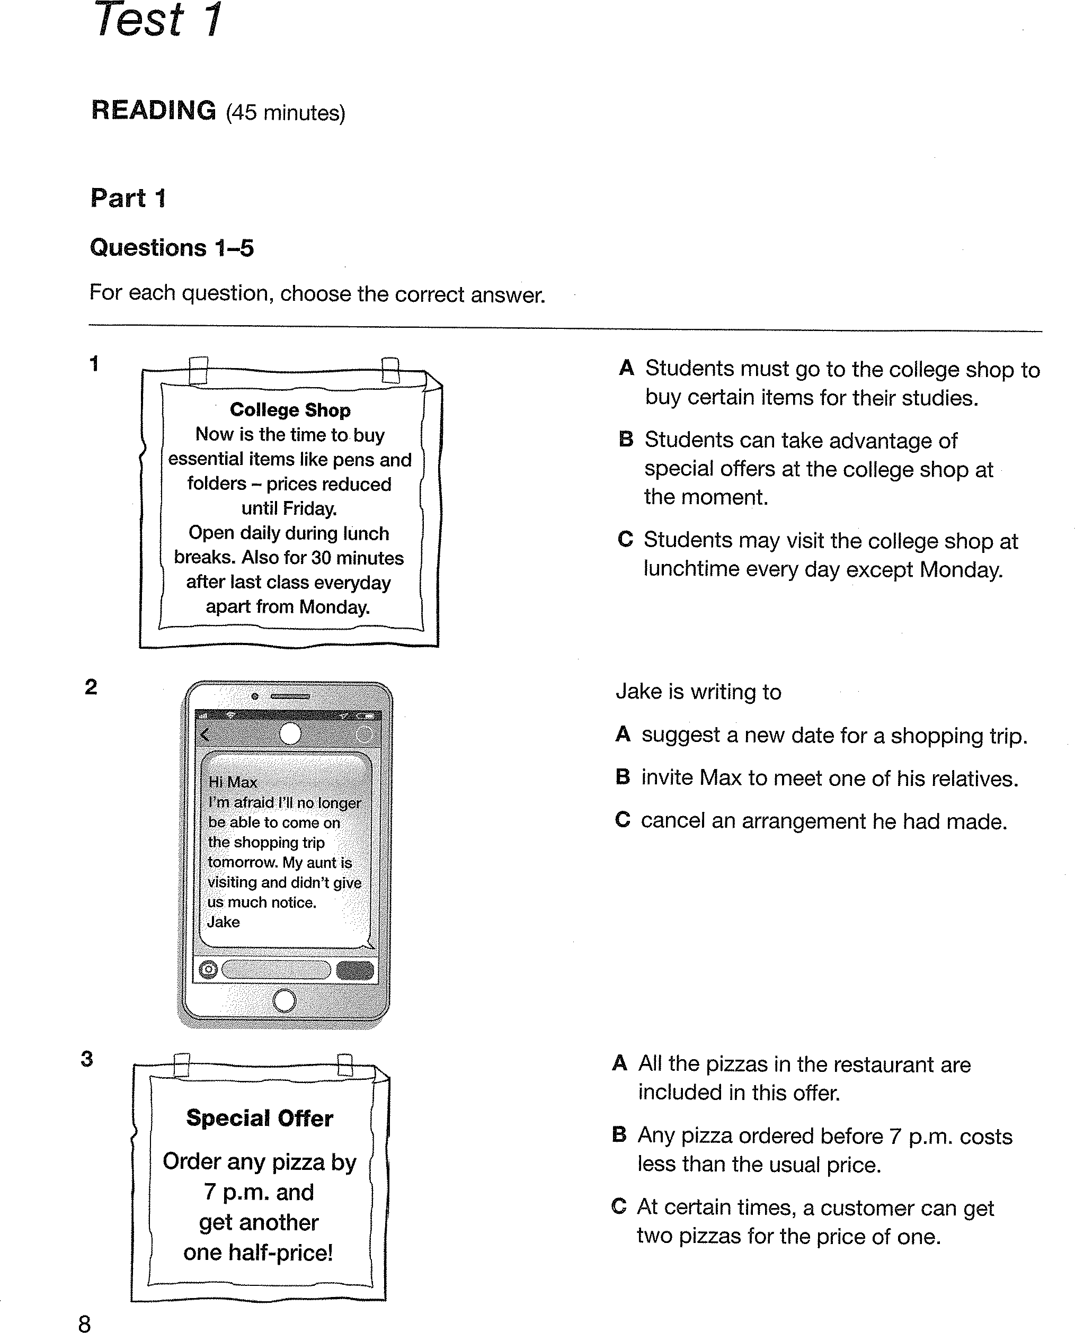

TEST 2 “If you can imagine it, you can achieve it. If you can dream it, you can become it.”
MULTIPLE CHOICE QUESTIONS.
- A. notify B. over C. phone D. ordinary
- A. fertilizer B. appreciate C. facsimile D. endangered
- He took a(an) ______ interest in football. He never missed a match on television.
A. avid B. successful C. actually D. common
- Fossil fuels reserves are limited, so we are trying to find ______ sources of energy.
A. relative B. entire C. alternative D. demanding
- The person ______ is my sister.
A. from whom I got this parcel B. which I got this parcel from
C. I got this parcel from her D. from that I got this parcel
- Wind power produces energy ______ pollution.
A. by B. with C. without D. for
- The climbers ______ reach their tent safely despite the terrible weather.
A. could B. were able to C. can D. are able to
- Most of the waste paper _____ in our factories.
A. is recycled B. are recycled
C. is recycling D. have been recycling
- Nothing unusual happened, ______?
- did they B. didn’t they C. did it D. didn’t it
- A leg injury prevented him from active ______ in the competition.
A. participate B. participant C. participatory D. participation
11.The Great Pyramid of Giza, together with two other great pyramids, ___ built around 2500 B.C.
A. was B. has been C. were D. have been
12. When I turned the ignition key, the car was starting.
A B C D
13. “Betty, make me some tea, will you?!” “______”
A. No, I will, I’m afraid. B. I can’t, I’m afraid.
C. That’s very kind of you. D. Yes, go ahead.
14.“Thank you so much for your instructions.” “______”
A. That’s right B. Yes of course
C. Not too bad. Thanks. D. No problem. That’s a what I’m here for!
15. Uncle Ho was the president ______
A. we adore him B. whom we adore him C. we adore D. whom adores us
16. Try to ______ your time.
A. make use of B. indulge in C. by far D. interference with
17. ______ we arrived , the film had started already
A. Since B. By the time C. Until D. As soon as
18. Nobody knows who invented the wheel, ______?
A . does he B. doesn’t nobody C. don’t they D. do they
19. Teacher: “You are late for class,”- Student: ______.
A. “So am I” B. “ I hope you’ll forget my mistake.”
C. “Sorry about my absence” D. “ Sorry for being late.”
20. -Lan:” Do you feel like going to the stadium this afternoon? - Nam; “______”
A. I don’t agree. I m afraid. C. I feel very bored. B. That would be great. D. You’re welcomed.
21. He is really an accomplish dancer.
A B C D
22. A. exhausted B. indulged C. applied D. captured
23. A. knowledge B. landscape C. respect D. offspring
24. The employees ______ he employs are always complaining about their pay.
A. whom B. whose C. which D. when
25. It is said that there will be more new sports added ______ the Games.
A. in B. for C. to D. at
26. The old man is said ______ all his money to an old people’s home when he died.
A. to have left B. to leave C. to have D. to leaving
27. I saw a bad accident while I ______ for you on this corner.
A. was waiting B. waited C. am waiting D. have waited
28: _________my parents gave me the fish tank.
A. It was on my birthday when B. It was my birthday on that
C. It was my birthday that D. It was on my birthday that
29: The skyscraper is said to have been built in 1930.
A. They said that skyscraper was built in 1930. B. It was said that skyscraper was built in 1930.
C. They are said that skyscraper is built in 1930. D. It is said that skyscraper was built in 1930.
30: It is necessary that all high building be equipped _________smoke detectors.
A. for B. by C. with D. in
Read the following passage and choose the word or phrase that best fits
Fathers in today families are spending more time with their children than at any point in the past 100 years. (31) _______ the number of hours the average woman spends at home with her children has declined since the early 1900s, as more and more women enter the workforce, there has been a decrease in the number of children per family and an increase in (32) _______ attention to each child. As a result, mothers today in the United States, including those who work part- or full-time, spend almost twice as much time with each child as mothers did in the 1920s. People (33) _______ raised children in the 1940s and 1950s typically report that their own adult children and grandchildren communicate far better with their kids and spend more time helping with homework than they did.
America's children are also safer today than they've ever been. An infant was four times more likely to die in the 1950s than today. A parent then was 27 percent more likely (34) _______ an older teen to death. If we look back over the last millennium, we can see that families have always been diverse. In each period, families have solved one set of problems only to face new challenges. What works for a family in one economic and cultural setting doesn't work for a family in another. What's helpful at one stage of a family's life may be destructive at the next stage. If there is one lesson to be drawn from the last millennium of family history, it's that families always have to (35) _______ with a changing world.
Question 31: A. Although B. However C. Unless D. Besides
Question 32: A. isolated B. individual C. unique D. single
Question 33: A. whom B. which C. who D. when
Question 34: A. to lose B. losing C. lose D. to losing
Question 35: A. put up B. live up C. go up D. catch up
Read the following passage indicate the correct answer to each of the following questions.
During the teenage years, many young people can at times be difficult to talk to. They often seem to dislike being questioned. They may seem unwilling to talk about their work at school. This is a normal development becoming independent of teenagers trying to be adult while they are still growing up. Young people are usually more willing to talk if they believe that questions are asked out of real interest and not because people are trying to check up on them.
Parents should do their best to talk to their sons and daughters about school work and future plan but should not push them to talk if they don’t want to. Parents should also watch for the danger signs: some young people in trying to be adult may experiment with sex, drugs, alcohol or smoking. Parents need to watch for any signs of unusual behavior which may be connected with these and get help if necessary.
Question 36: The word “behavior” in the passage most nearly means _______.
A. feeling B. manners C. activities D. reaction
Question 37: Why do adults sometimes find teenagers difficult to talk to ?
A. Because most teenagers are quiet
B. Because teenagers don’t want to talk to other people
C. Because teenagers think adults are not honest
D. Because most teenagers hate adults.
Question 38: What does the word “they” in bold in paragraph 1 refer to _____ ?
A. parents B. future plan C. school work D. teenagers
Question 39: When can you expect young people to be more talkative than usual?
A. when people talk to them because they are really interested and not just checking on them.
B. when adults give them a lot of money to spend
C. when adults talk to them about something other than their work in school.
D. when adults talk to them about sex, alcohol and drugs
Question 40: When is it necessary for parents to find help for their child ?
A. When the teens starts taking up smoking B. When it’s difficult to communicate with
C. When they don’t have future plans D. When they have low marks in school
IV. WRITING: Do as directed.
1. Anna is my distant cousin. Her daughter is a famous pianist. (using relative clause)
=> We ………………………………………..…………………………………….………………………
2. “On the ground” solo single is the highest charting debut by a Korean woman in U.S chart history. ( using cleft sentence)
=> It ………………….…………………………………………………..…………………………………
3. It is said that Rose’ is the most attractive singer in Black Pink band . ( passive voice)
=> Rose’ …………………………………………………………………………………………………………
4. Son Tung MTP lives in the luxury building which was painted blue. ( reduce relative clause)
=> The ……………..………………………………………………………………………………………

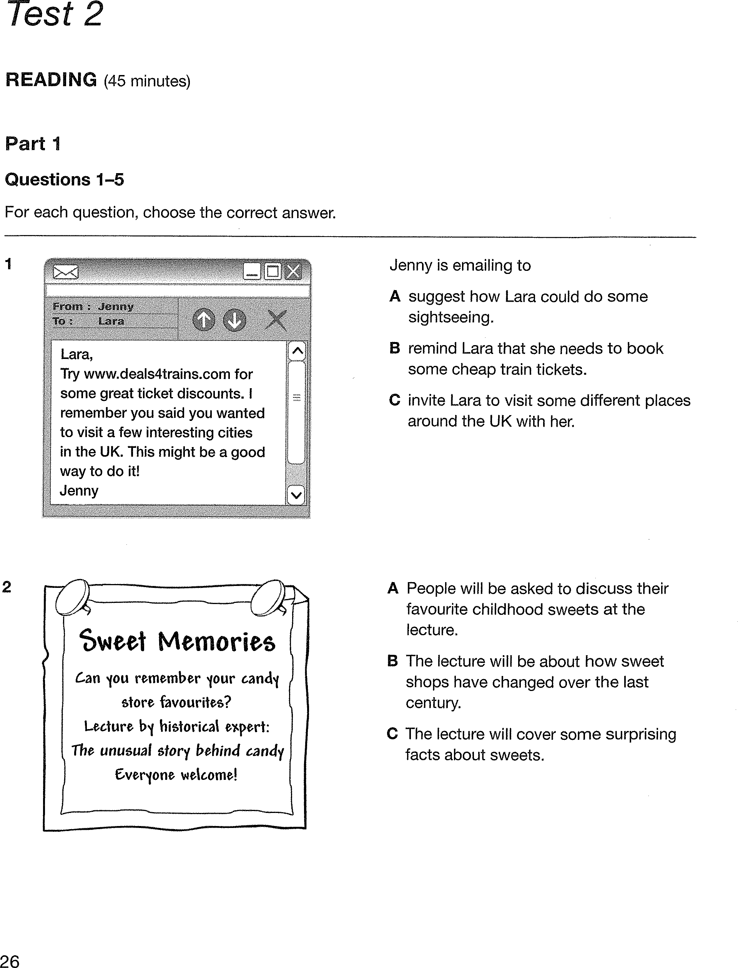

TEST 3 --------Nothing is impossible. The word itself “I’m possible”
1. A. danced B. opened C. pleased D. ploughed
2. A. conquest B. device C. effort D. purpose
3. If the atmosphere is ______ the solar energy that reaches the earth may be dangerous.
A. pollute B. polluting C. pollution D. polluted
4. Park Hang Seo, who is the head______ of the Viet Nam national football team, is loved by most Vietnamese people.
A. coach B. manager C. referee D. trainee
5. She made it clear that her comments were strictly off the______. She did not want them to be repeated publicly
A. file B. inbox C. handbook D. record
6. She is a very accomplished pianist. The word “accomplished” is closest in meaning to” _______”.
A. admired B. skilled C. talent D. well
7. I got stuck in the traffic jam last night. Before I ______ to the wedding, half of guests ______.
A. got/were leaving B. got/had left C. had got/ left D. was getting /had left
8. As soon as Joanne opened the door, she ______ smell something burning.
A. could B. was able to C. can D. would be able to
9. Governments can pass and enforce laws that requiring businesses and individuals to stop, or to cut down on certain polluting activities.
A. that requiring B. to stop C. to cut down D. polluting
10. The notice say: “150 OLD COMICS FREE TO FIRST CALLER!”
Phone number: 022879
A. Phone quickly to get lots of funny short stories to read
B. Make a phone call and get 150 comics at any time
C. When you pay for your call, you will also get free funny books
D. If your telephone number is 022879, you will get 150 comics
11. We should never indulge ourselves _______ anything that can form a bad habit.
A. in B. on C. for D. at
12. The problem _________ he was trying to deal was so complicated.
A. in which B. with which C. for which D. by which
13. Jolie and Tom are talking about sports.
Tom: "______ volleyball is a good sport to promote teamwork at school" Jolie: "You can say that again"
A. As far as I concern B. In my opinion
C. In my opinion, I think D. Should I think
14. Lan rarely misses her breakfast before leaving for school ________?
A. does Lan B. doesn’t Lan C. does she D. doesn’t she

III. READING:
A hobby is a regular activity done for enjoyment, typically during one's leisure time. Hobbies include collecting themed items and objects, engaging in creative and artistic pursuits, playing sports, or pursuing (15)_________ amusements. Participation in hobbies encourages acquiring substantial skills and knowledge in that area. A list of hobbies changes with renewed interests and developing fashions,(16)__________ it diverse and lengthy. Hobbies tend to follow trends in society, for example stamp collecting was popular during the nineteenth and twentieth centuries as postal systems were the main means of communication, while video games are more popular nowadays following technological advances. The advancing (17)____________ and technology of the nineteenth century provided workers (18)____________ more availability in leisure time to engage in hobbies. Because of this, the efforts of people investing in hobbies has increased with time.
Hobbyists may be identified under three sub-categories: casual leisure, serious leisure, and project-based leisure. Though, some hobbyists engage in leisure pursuits (19)_________- overlap multiple boundaries of the groups. Hobbies are mostly found within the second category, serious leisure.

15. A. another B. other C. others D. the others

16. A. make B. to make C. making D. made

17. A. produce B. producer C. product D. hunt

18. A. for B. in C. to D. with

19. A. which B. who C. whom D. whose

Read the following passage to indicate the correct answer to each of the questions.
Recent technological advances in manned and unmanned vehicles, along with breakthroughs in satellite technology and computer equipment, have overcome some of the limitations of divers and diving equipment for scientists doing research on the great oceans of the world. Without a vehicle, divers often became sluggish, and their mental concentration was severely limited. Because undersea pressure affects their speech organs, communication among divers has always been difficult or impossible. But today, most oceanographers avoid the use of vulnerable human divers, preferring to reduce the risk to human life and make direct observations by means of instruments that are lowered into the ocean, from samples taken from the water, or from photographs made by orbiting satellites. Direct observations of the ocean floor can be made not only by divers but also by deep-diving submarines in the water and even by the technology of sophisticated aerial photography from vantage points above the surface of more than seven miles and cruise at depths of fifteen thousand feet. In addition, radio-equipped buoys can be operated by remote control in order to transmit information back to land-based laboratories via satellite. Particularly important for ocean study are data about water temperature, currents, and weather. Satellite photographs can show the distribution of sea ice, oil slicks, and cloud formations over the ocean. Maps created from satellite pictures can represent the temperature and the color of the ocean's surface, enabling researchers to study the ocean currents from laboratories on dry land. Furthermore, computers help oceanographers to collect, organize, and analyze data from submarines and satellites. By creating a model of the ocean's movement and characteristics, scientists can predict the patterns and possible effects of the ocean on the environment.
Question 20: With what topic is the passage primarily concerned?
A. Communication among drivers.
B. Technological advances in oceanography
C. Direct observation of the ocean floor.
D. Undersea vehicles.
Question 21: The word “sluggish” is closest in meaning to .
A. nervous B. confused C. slow moving D. very weak
Question 22: This passage suggests that the successful exploration of the ocean depends upon.
A. the limitations of diving equipment
B. radios that divers use to communicate
C. controlling currents and the weather
D. vehicles as well as divers
Question 23: Divers have had problems in communicating underwater because .
A. the pressure affected their speech organs
B. the vehicles they used have not been perfected
C. they did not pronounce clearly
D. the water destroyed their speech organs
Question 24: Undersea vehicles .
A. are too small for a man to fit inside
B. are very slow to respond
C. have the same limitation that divers have
D. make direct observations of the ocean floor

IV. WRITING: Do as directed.
1. Mr. Jones is one of my teachers of English. He has decided to come to live in our city (using relative clause)
=> We ………………………………………..…………………………………….………………………
2. The unique structure of the Great Pyramid of Giza has attracted many researchers in the world. ( using cleft sentence)
=> It ………………….…………………………………………………..…………………………………
3. It is said that there is an increase in violence in some schools now. ( passive voice)
=> There……..………………………………………………..…………………………………………
4. We have got some English tasks that we must finish before Monday. ( reduce relative clause)
=> The Great Pyramid of Giza ……………..…………………………………………………………………

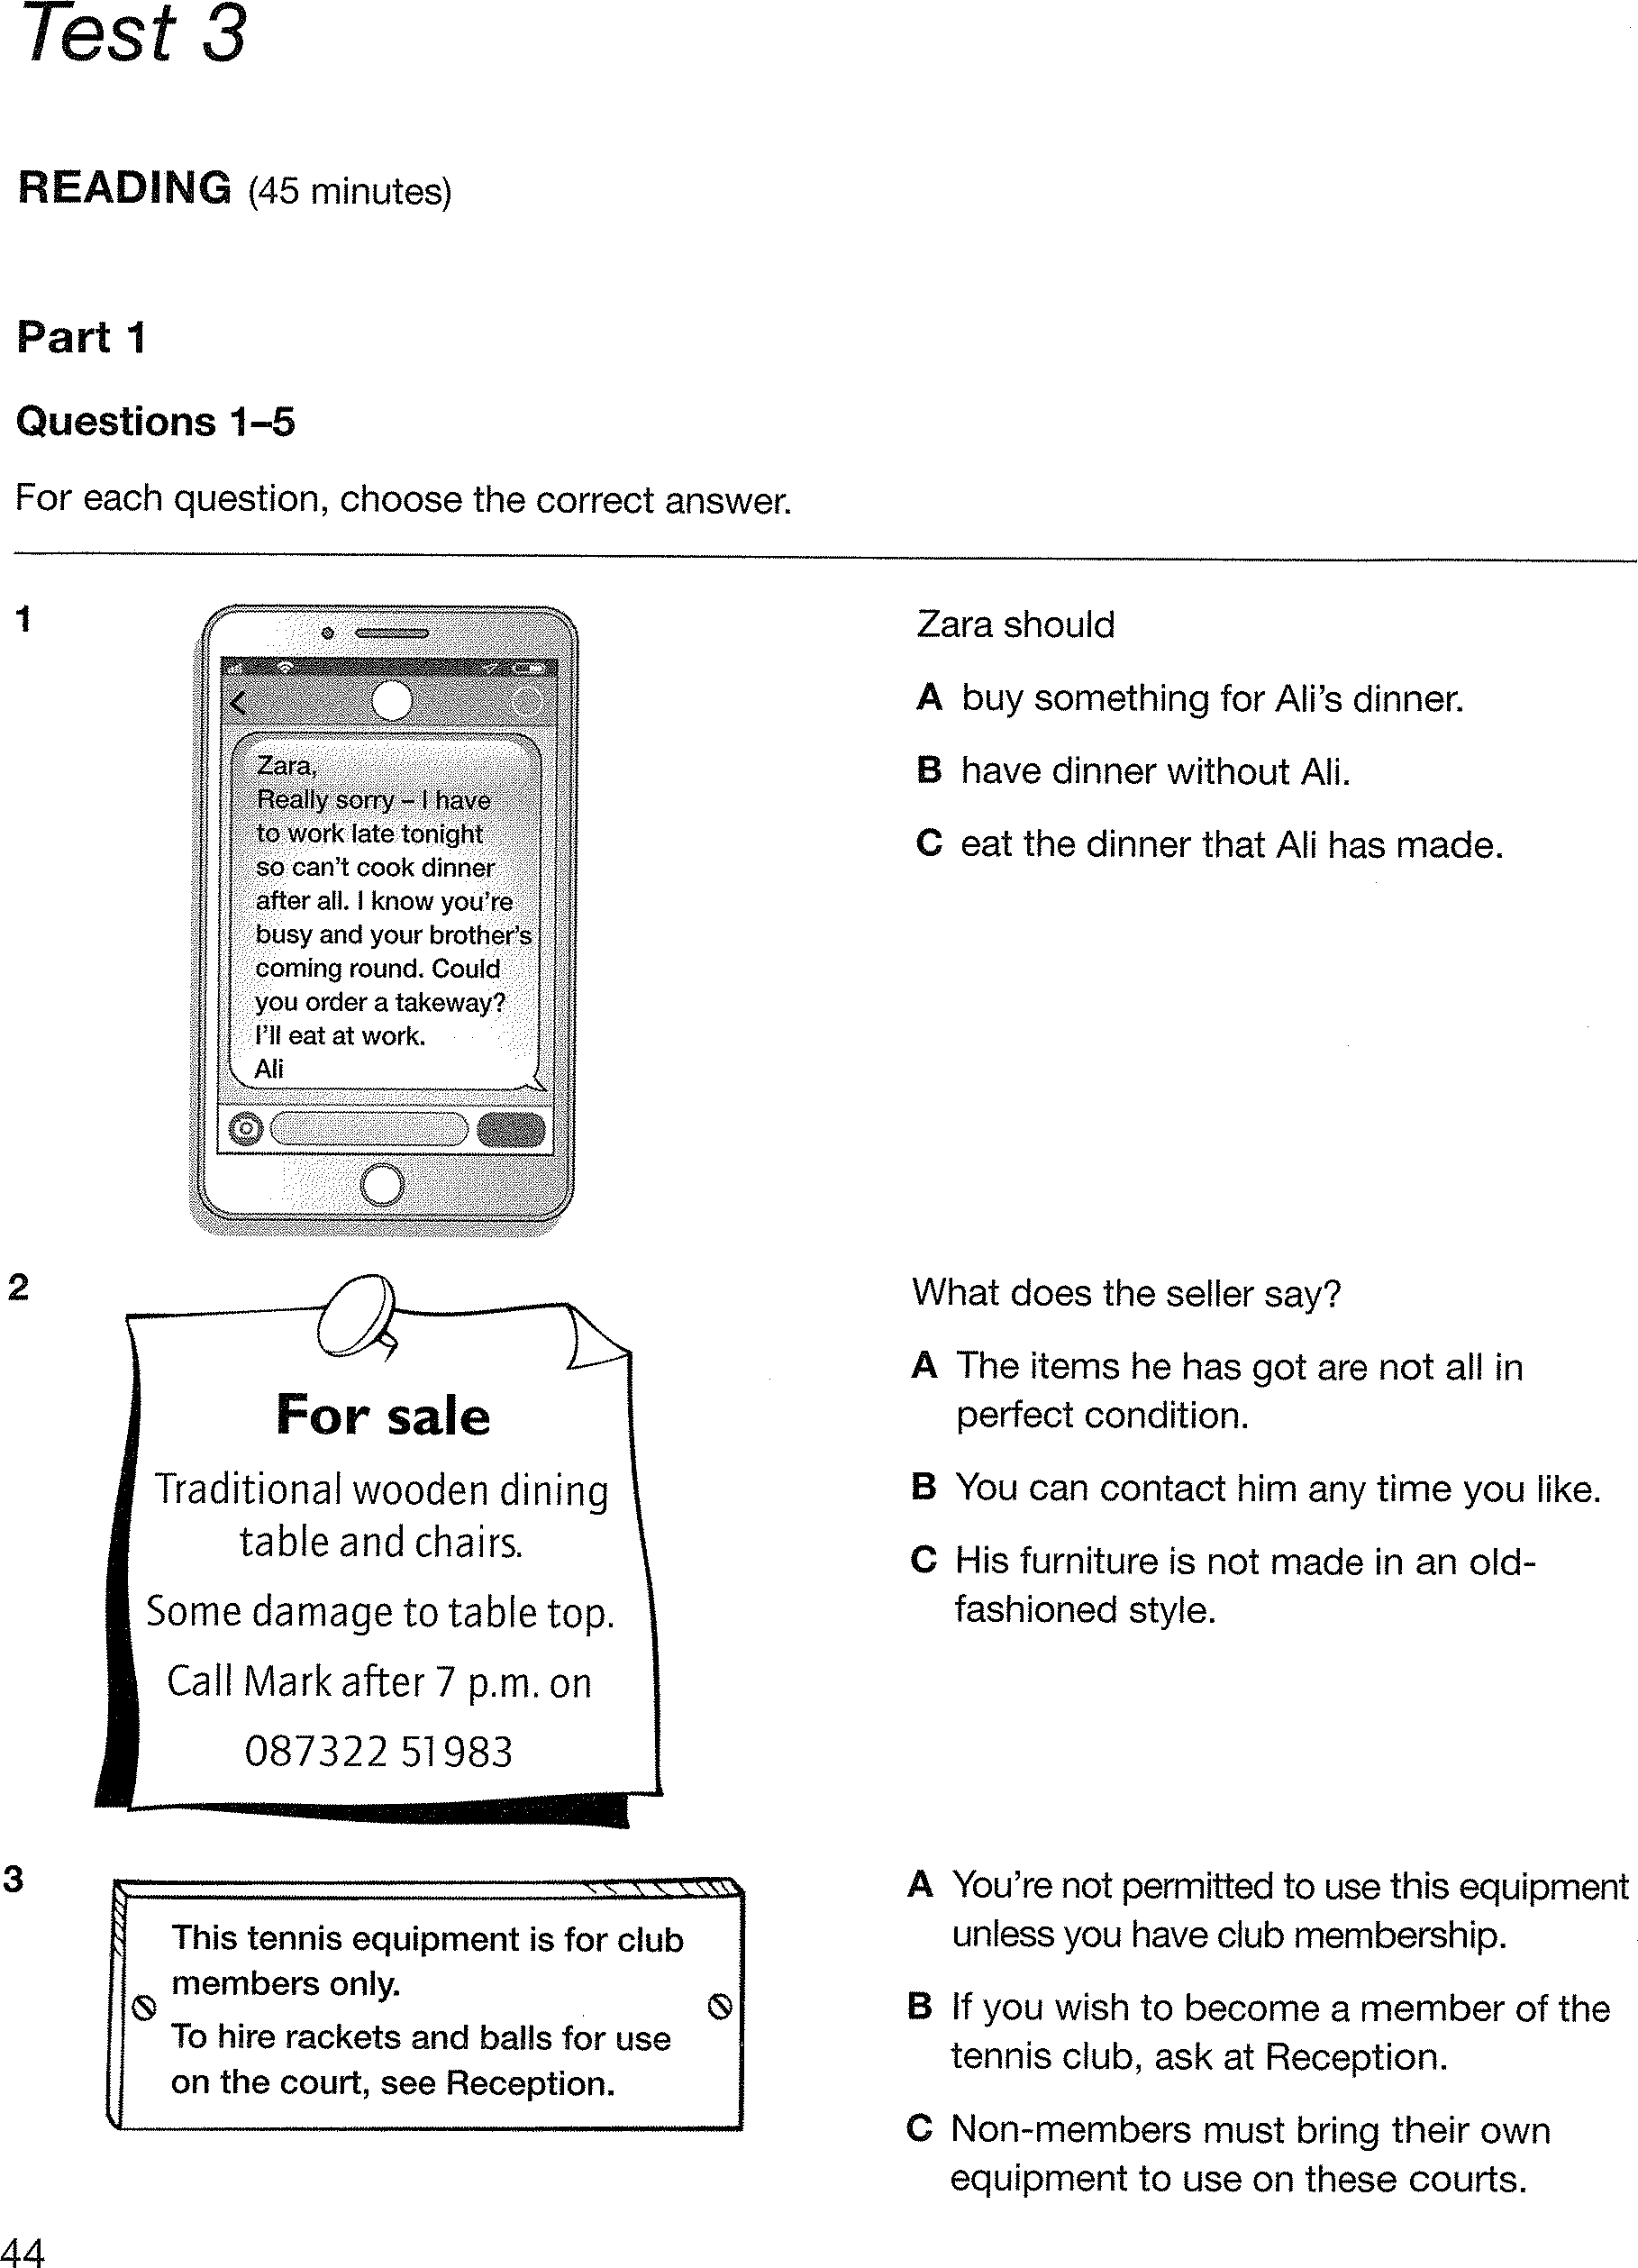

TEST 4
Life is short. Live it. Fear is natural. Face it. Memory is powerful. Use it.
Mark the letter A, B, C or D to indicate the word whose underlined part differs from the other
Question 1: A. energy B. supply C. dirty D. happy
Question 2: A. pear B. spear C. bear D. swear
Question 3: A. swing B. sweat C. swan D. answer
Question 4: A. needs B. meets C. skills D. loves
Question 5: A. watched B. forced C. worked D. solved

Question 6: Hunting for meat and burning forests for soils __________ wildife.
A. protect B. conserve C. destroy D. survive
Question 7: I would like to send these letters ____________ air mail .
A. in B. with C. by D. over
Question 8: The government sent money and food to the people __________ houses were destroyed by the storm last week.
A. which B. that C. whom D. whose
Question 9: Human beings have great __________ on the rest of the world.
A. focus B. attention C. influence D. attraction
Question 10: He is the postman ___________ I got this letter.
A. from who B. to whom C. from whom D. with whom
Question 11: Coal, oil, and forests are the most important ___________ resources.
A. industrial B. agricultural C. natural D. national
Question 12: It's the best film ___________ has ever been made about madness.
A. which B. whom C. whose D. that

Question 13: Thanh Ba Post Office provides customers ____________ the Messenger Call Services.
A. with B. for C. of D. to
Question 14: The energy ____________ by the windmill drives all the drainage pumps.
A. producing B. produced C. that is producing D. which produces
Question 15: The human race is only one small species in the living world. Many ___________ species exist on this planet.
A. the others B. others C. the other D. other
Question 16: We have stopped buying goods from that shop as most of them are __________ poor quality.
A. in B. under C. with D. on
Question 17: Being recognized in the street is part and ____________ of being a celebrity
A. packet B. parcel C. package D. post
Question 18: ____________ national parks all over the world have been established to protect endangered animals.
A. Thousand B. Thousands C. Thousands of D. Thousand of
Question 19: We are proud of our _________ staff, who are always friendly and efficient.
A. well-appointed B. well-done C. well-behaved D. well-trained
Question 20: _________ is a great source of energy but very dangerous.
A. Solar energy B. Water power C. Nuclear power D. Wind energy
Question 21: The receptionist didn’t know ____________ whom the message was intended.
A. at B. with C. to D. for
Question 22: The sun, water and the wind are other __ sources of energy.
A. renewable B. reused C. alternative D. exhausted
Question 23: It __________ a lot of patience to be a nurse.
A. takes B. spends C. costs D. uses
Question 24: It is estimated that only 1,000 pandas remain in __________ wild.
A. a B. an C. no article D. the
Question 25: The situation of COVID-19 worldwide is still serious, ___________ ?
A. is not it B. isn’t it C. is it D. doesn’t it

Question 26: Cindy wanted to drive her best friend to have dinner at an Italian restaurant but her car couldn't start. Therefore, she had to borrow one from Nancy.
- Cindy: "Would you mind lending me your car?"
- Nancy: " ____________ . "
A. Great B. Yes. Here it is C. Yes, let's D. No, not at all.
Question 27: Peter and John are in a café.
Peter: "What's your favourite pastime?"
John: " "
A. My past time is nice. B. Ok, I like it. C. I beg your pardon. D. I worked hard in the past.

Question 28: Factories located on the coastline have released untreated pollution directly into the ocean.
A. located B. have released C. pollution D. directly
Question 29: Radio stations at which broadcast only news first appeared in the 1970s.
A. at which B. only news C. appeared D. the
Question 30: Reading books, listening to music and play sports are among the most popular leisure activities.
A. play B. are C. the D. leisure activities
Mark the letter A, B, C, or D is CLOSEST in meaning to the underlined part
Question 31: If the world’s tropical forests continue to disappear at their present rate, many animal species will become extinct.
A. die for B. die from C. die of D. die out
Question 32: Oil spills are having a devastating effect on coral reefs in the ocean.
A. powerful B. significant C. disastrous D. detectable
Question 33: Newspapers and magazines are often delivered early in the morning.
A. offered B. given C. provided D.distributed
Read the following passage and mark the letter A, B, C, or D
Human beings (34)__________ to protect only the beautiful and non-threatening parts of our environment. We tend to pay more (35)________ to animals on land than any other large sea animals. Environmentalists have not done much enough to help save the Pacific Ocean sharks (36)_________ population has decreased nearly to the point of extinction.
Sharks are among the oldest creatures on Earth, having survived in the seas for more than 350 million years. The fact that they have managed to live in the oceans for so many millions of years is enough proofs of their efficiency and adaptability to change environments.
It’s time (37)_________ human beings to begin considering the protection of sharks as (38)______ important part of a program for protection of our natural environment.
Question 34: A. seem B. make C. advise D. let
Question 35: A. pleasure B. attention C. notice D. fun
Question 36: A. that B. whom C. whose D. which
Question 37: A. for that B. when C. for which D. for
Question 38: A. No article B. an C. the D. a
Read the following passage and mark the letter A, B, C or D
Energy is fundamental to human beings, especially to poor people – the one-third of humanity that does not have modern energy supplies like electricity or natural gas, with which their life could be improved.
Many people who live in countryside and mountainous areas have to gather fuel wood. This takes a lot of time. Moreover, it causes indoor air pollution because of heavy smoke. For many people living in rural areas in developing countries of the world, biogas is the large energy resources available and costs almost nothing. The main use of biogas is for cooking and heating, but it can also provide energy for public transport. As biogas is smoke-free, it helps solve the problem of indoor air pollution. Moreover, plant waste and animal manure cost almost nothing.
The tendency to use renewable energy sources in developing countries is on the increase when non-renewable ones are running out. In the near future, people in the developing countries may use wind or sea waves as the environment-friendly energy sources.
Question 39: What is the role of energy to human beings?
A. unimportant B. fundamental
C. unnecessary D. not very necessary
Question 40: What do poor people in countryside do to have energy?
A. They look for coal B. They look for oil
C. They gather fuel wood D. They use gas cookers
Question 41: How long does it take to gather fuel wood in the countryside?
A. A lot of time B. Not much time
C. Very little time D. Half an hour a day
Question 42: According to the passage, what energy sources do poor people often use for fuel?
A. oil B. wood B. nuclear energy D. petrol
Question 43: According to the passage, what is the most awful effect of using fuel wood?
A. It may cause fire. B. It damages their houses.
C. It affects the local scenery. D. It causes indoor air pollution
Question 44: What is the main use of biogas?
A. It is used mainly for cooking and heating B. It is mainly used for lighting.
C. It is mainly used for operating. D. It is mainly used for producing in factories.
Question 45: Why, according to the passage, is biogas introduced to poor people?
A. Because it is easy to use
B. Because it is the largest energy resource available in the countryside and cheap
C. Because it is not harmful D. Because they like it
WRITING: Do as directed
46: Romeo and Juliet is a famous play . Shakespeare wrote it in 1605 . (using relative clause)
=> ……………………………………………….……………………………………………………
47: Sue lives in this house. The house is opposite my house. ( relative clause)
=> ………………………………………..…………………………………….……………………………………
48: The boy is called Duncan. He sits next to me in class. (using relative clause)
=> ………………………………………..…………………………………….……………………………………
49. His parents usually took him to the zoo when they lived in Lang Cat. ( using cleft sentence)
=> It ………………….…………………………………………………..……………………………………………
50. People rumored that Bill Gates was the richest man in the world. ( passive voice)
=> Bill Gates……..………………………………………………..……………………………………………………
51. The building in front of you was the first high rise building that was constructed in the neighborhood. ( reduce relative clause)
=> The building ……………..………………………………………………………………………

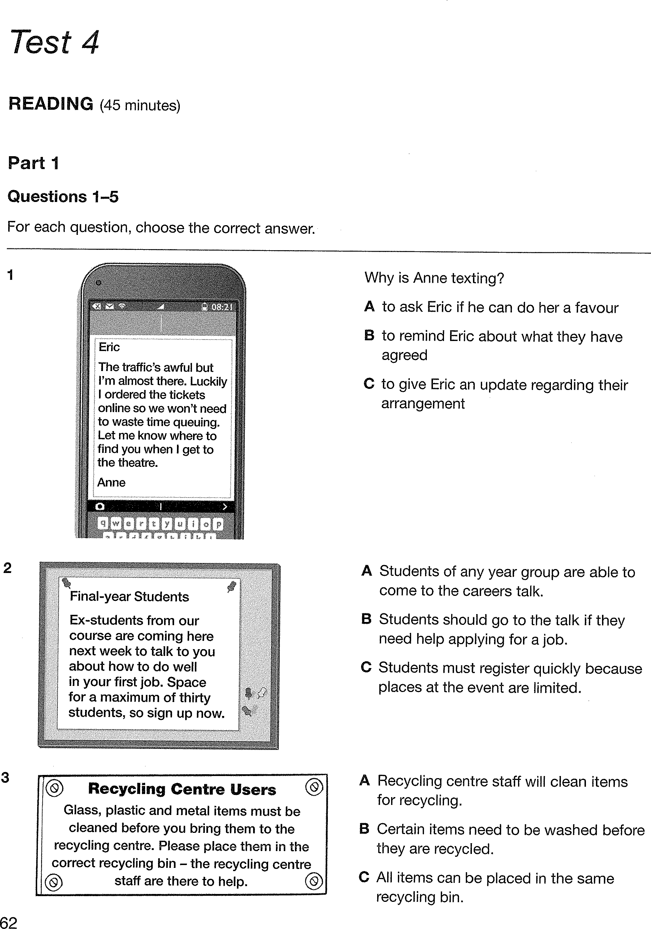

LISTENING PRACTICE
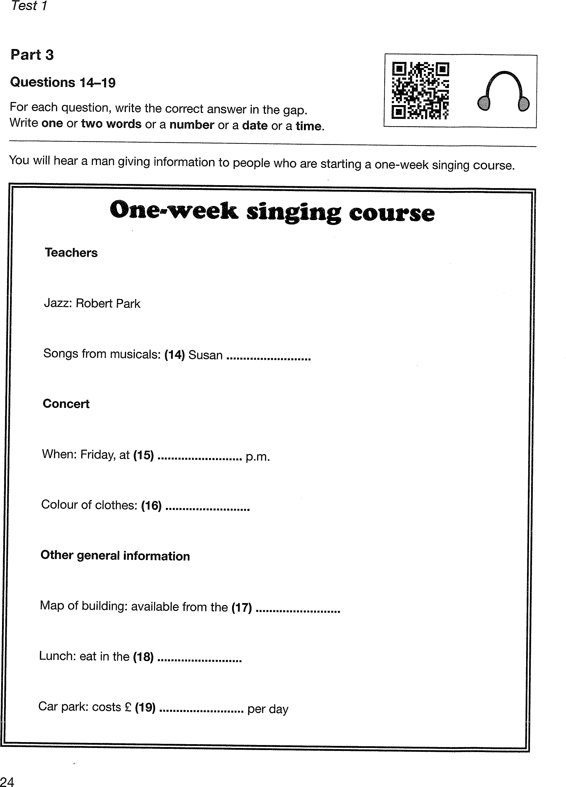
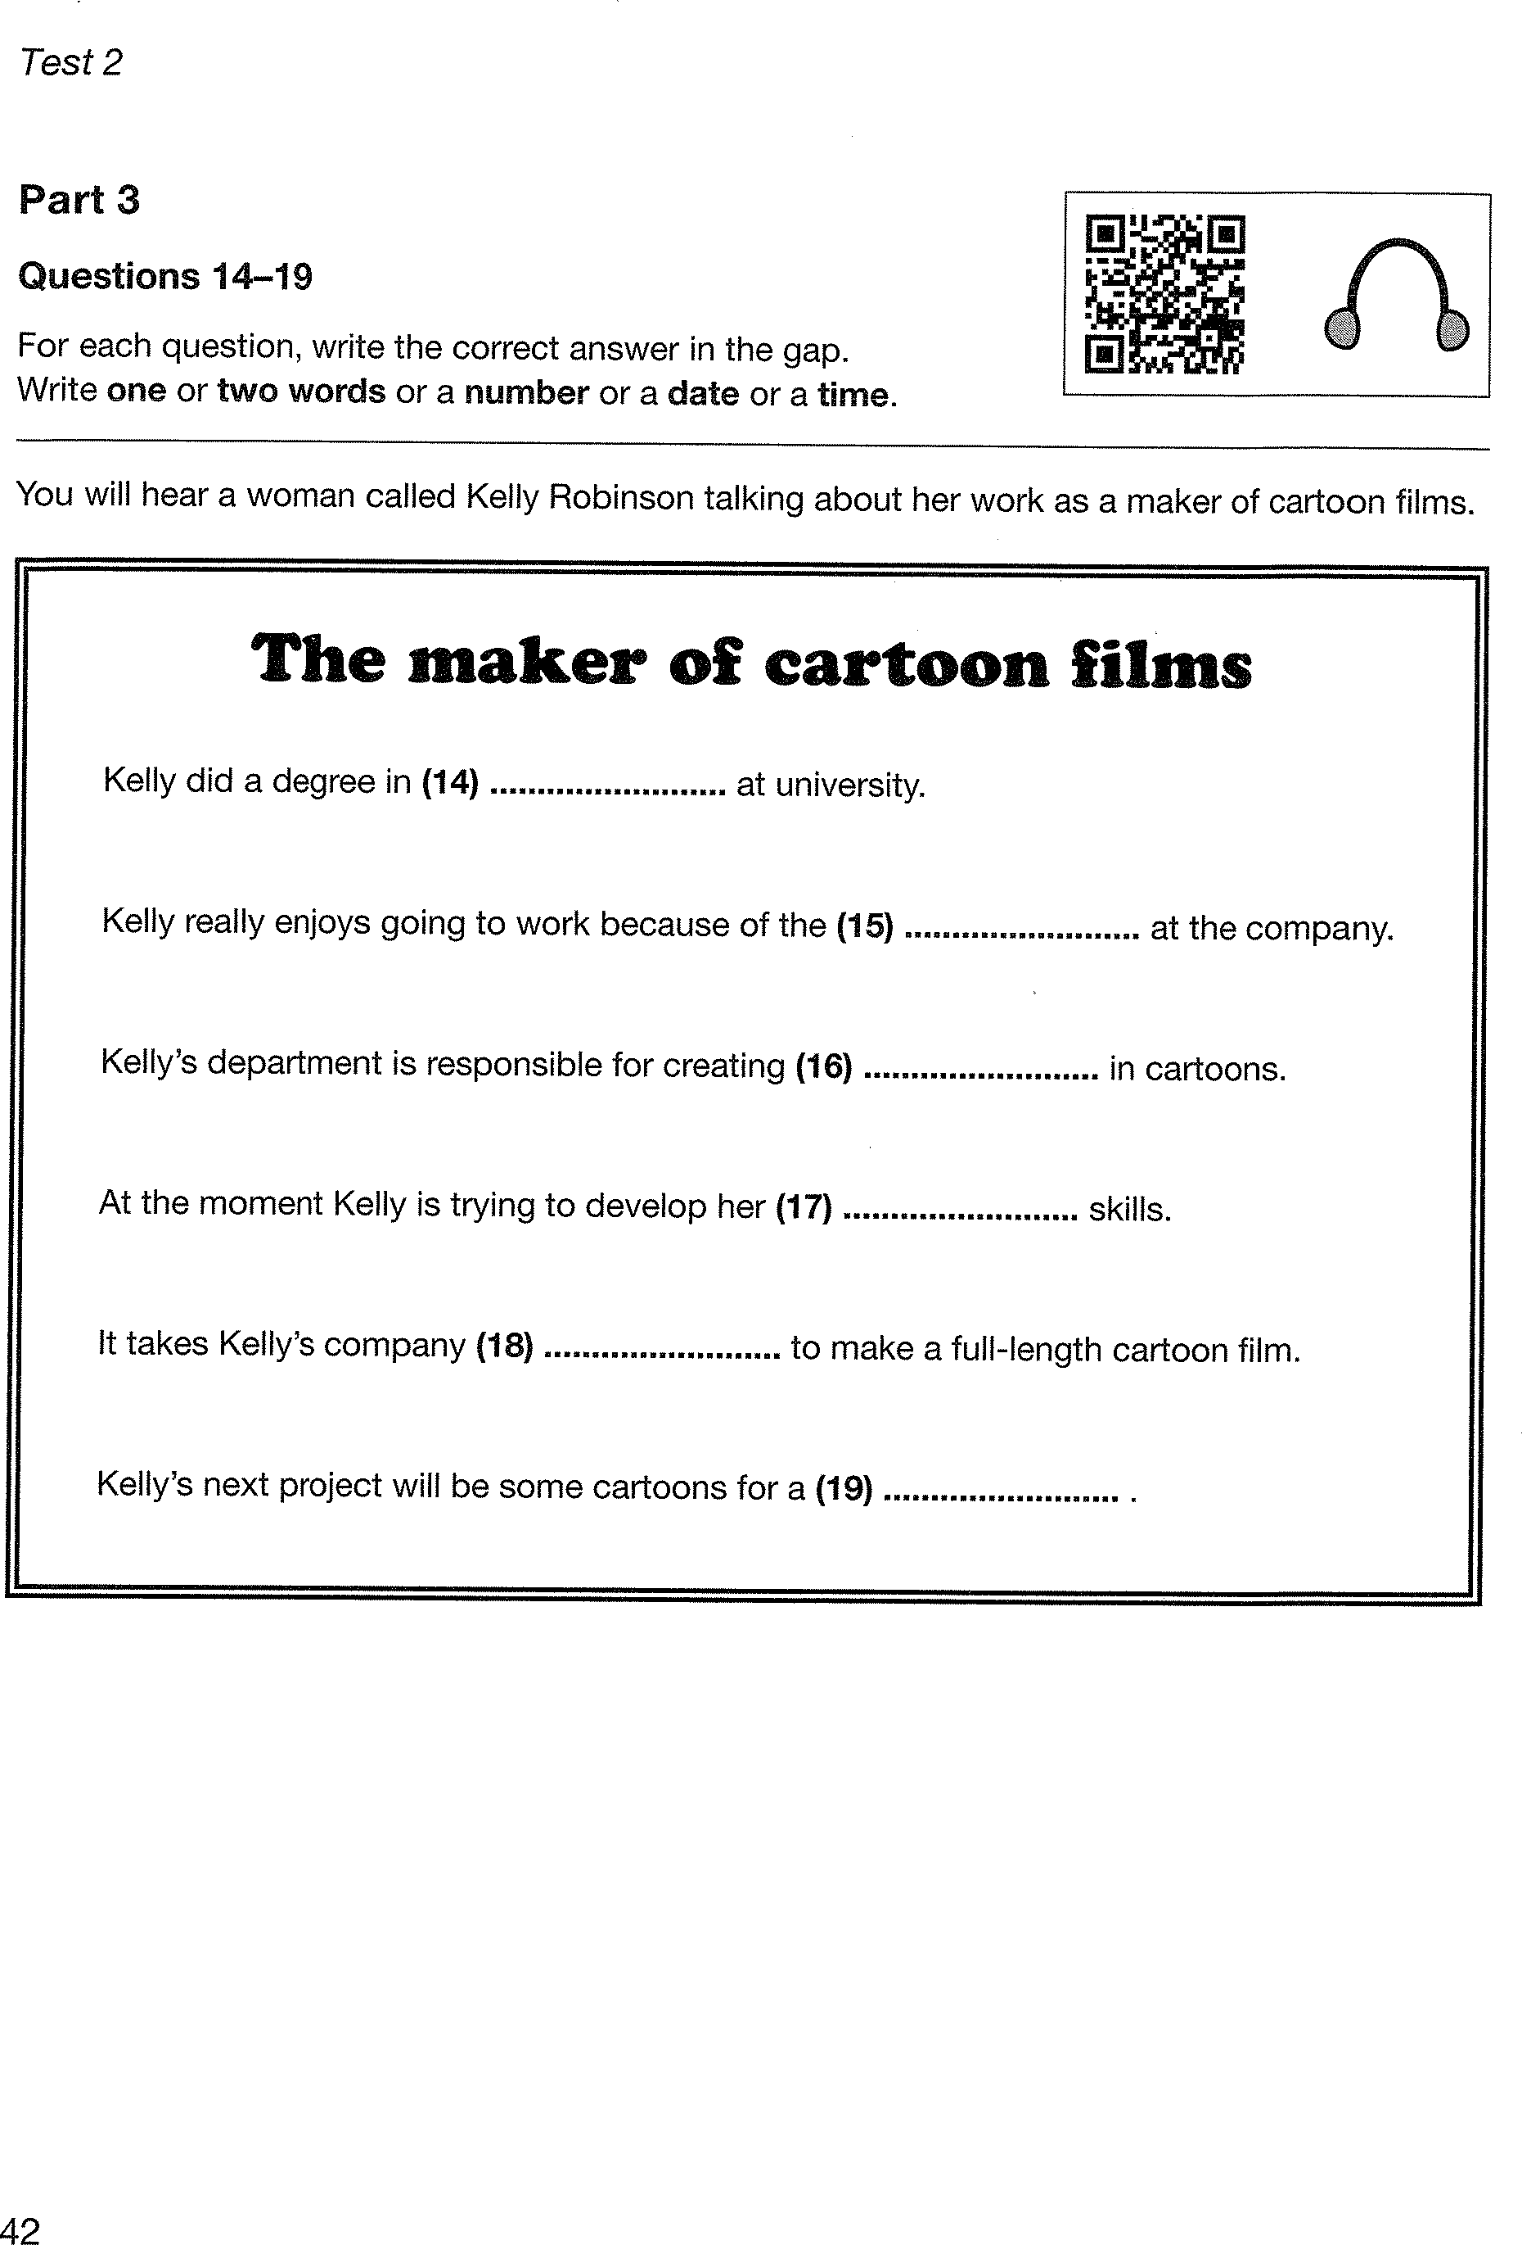

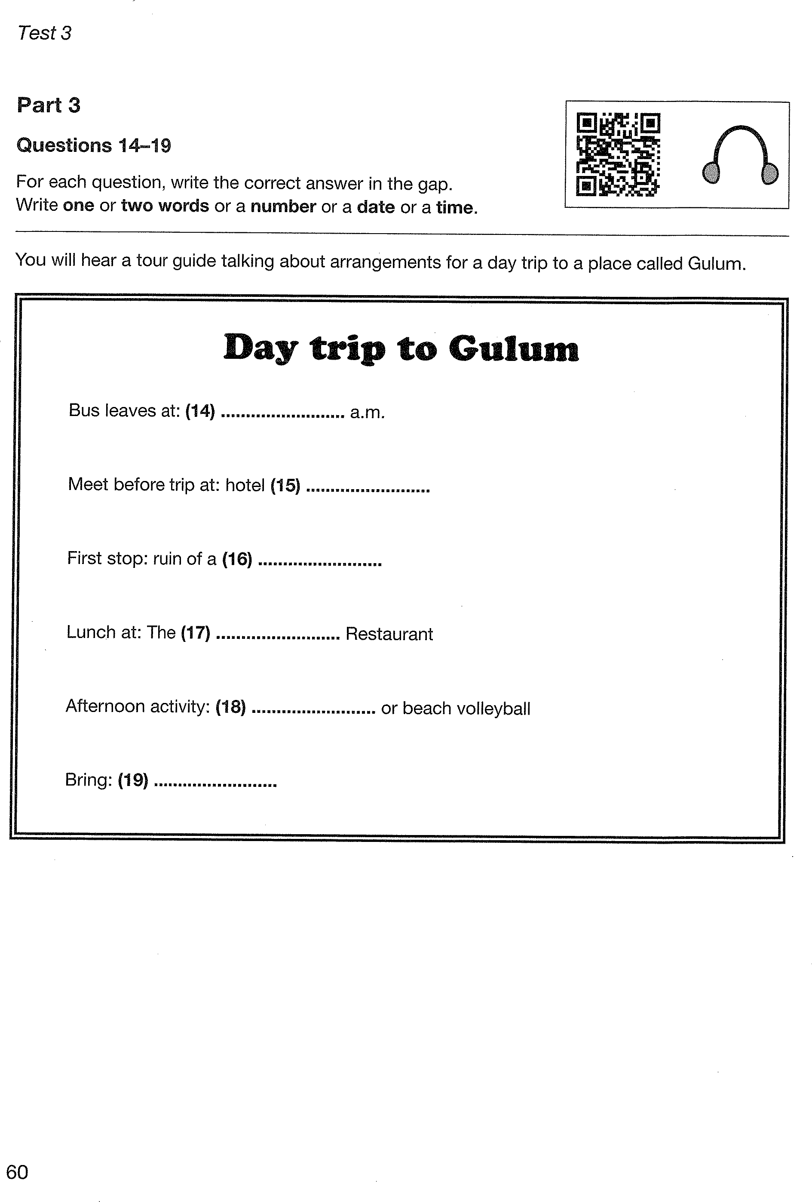

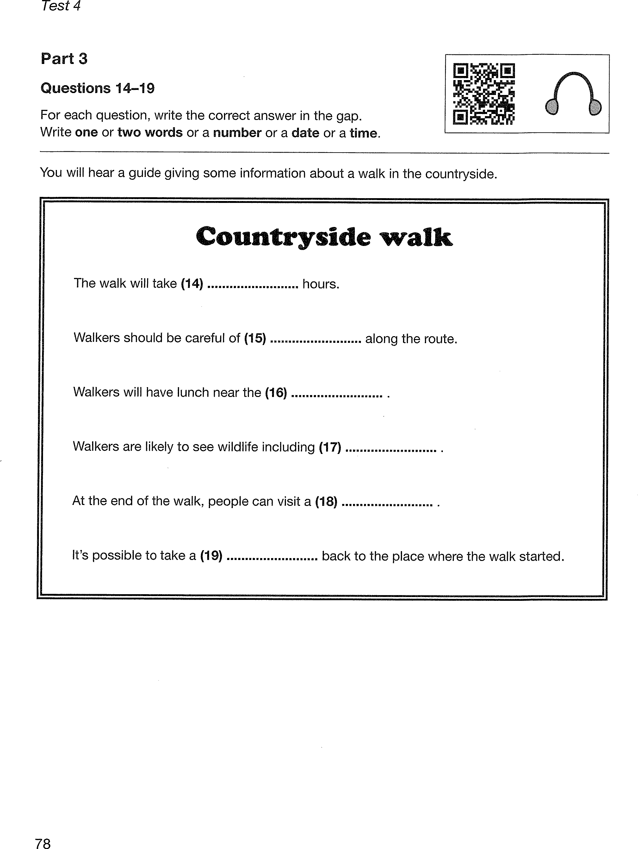

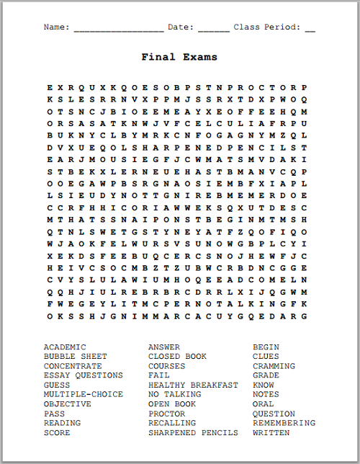
BREAK A LEG

